Science curriculum – Long term September 2022
 | Robins EYFS | Doves Yrs 1&2 | Owls Ysr 3&4 | Swans Yrs 5&6
Autumn 1 | 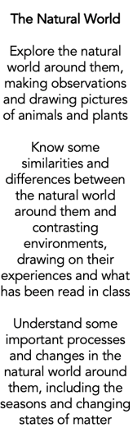 | Animals including humans | Introduce rocks | Living things and their habitat (revisit)
Autumn 2 |  | Everyday materials (revisit) | Living things and their habitat | Light
Spring 1 |  | Plants | Functions of parts of a plant | Animals including humans
Spring 2 |  | Use of everyday materials | Animals including humans | Animals including humans – water transportation.
Summer 1 |  | Living things and their habitat | Forces and magnets | Flexible
Summer 2 |  | (Flexible) | Sound & light  Electricity | Evolution and inheritance

